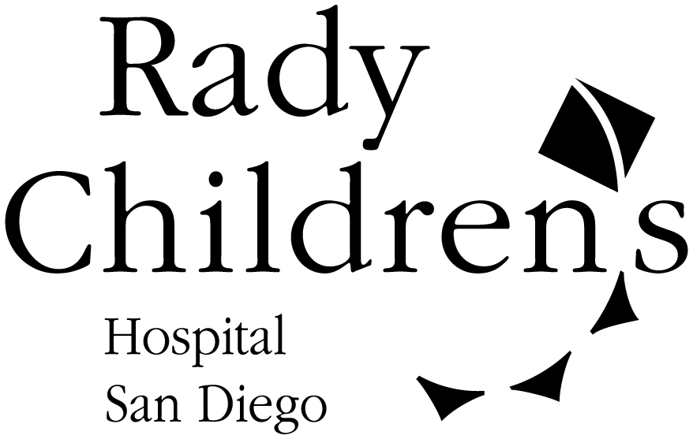

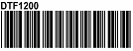
ADDENDUM CONSENT
PATIENT INFORMATION
Rady Children’s Hospital-San Diego
3020 Children’s Way
San Diego, CA. 92123

Study Title

You are currently participating in the study titled, “_____________________.” This study involves ____________________________. You and your parent decided that you could be in this study. However, s
ince you are now 18 years of age, we are required to make sure that you still want to be in this study and obtain your consent and authorization to continue your participation.

STUDY INVESTIGATOR AND SPONSOR

Investigator(s):

Sponsor:

WHY IS THIS STUDY BEING DONE?

[Please re-summarize the objectives of the study in lay language]

This study is being done to find out ………

HOW MANY WILL TAKE PART IN THE STUDY?

___ children and adults will be in this study at Rady Children’s Hospital-San Diego. ____ children and adults will be in the study at all the study sites combined. [Please include the number of subjects to be enrolled at CHHC, and total nationwide, as applicable.]

HOW LONG WILL YOU BE IN THE STUDY?
[Please focus on the remaining study period.]

You will be in the study for ___ weeks/days/months.

You can stop your participation at any time. However, if you decide to stop participating in the study, please talk to the research doctor. [Please include whether there are any procedures the subject must undergo if they withdraw or are terminated from the study (e.g., blood draw, physical, to monitor safety).]

WHAT IS INVOLVED IN THE STUDY?

This is what will happen if you continue to participate in this study:

Study Visit X: (please indicate time point such as Day 21 or Week 10): These tests will be done at this visit.

[If samples will be collected and discarded at the end of the study insert this statement-specify type of sample] The (blood and tissue) samples that are collected for this study will be used for the study as stated in this form. Any samples that are not used will be destroyed at the end of this study.

[If the data and/or specimens collected will be retained/banked for future research (not part of this study) revise and retain this statement accordingly. Also include whether this data/specimens will be sent elsewhere or retained at Rady Children’s.] When this study ends, the information and blood samples that are collected in this study may also be kept for new research studies. [Please also specify what identifiable data, if any will be retained] [If this is an optional component, option boxes should be included.}

[If specimens will be retained include this statement] The samples (specify types) that are collected from you for this study may have commercial (selling), diagnostic or therapeutic (treatment) value. This may be benefit the individuals who develop it. The Sponsor and/or study team do not intend to provide any benefits, financial or otherwise, to you from any of these developments. [If these specimens can be destroyed should the subject change his/her mind at a later date please indicate such and specify who should be contacted. If s/he cannot this must also be stated, e.g., Once the samples are collected you will not have further access to them, since we will be unable to identify your sample. (This would be appropriate if the samples are de-identified (not coded)).]

WHAT ARE THE RISKS OF THE STUDY?
[If there is statistical data available, please note the likelihood of these risks as specifically as available (e.g., headache 1 in 50, vomiting 5%, etc...).]

New risks have not been identified during your participation in this study. The study risks include:

The most common side effects seen with _____ are:

Side effects seen less often are:

If you have any illness or discomfort as a result of using the study drug or from any of the study procedures call the study doctor immediately. If necessary, using the study drug may be stopped and other treatment may be started.

Possible side effects from drawing blood include:
- feeling faint or lightheaded
- irritation of the vein where the needle enters the skin, such as redness or swelling
- pain, bruising or bleeding where the needle enters the skin and surrounding area
- a slight chance of infection where the needle enters the skin

If you use the numbing cream for the blood draw(s) your skin may temporarily turn red, white or develop a rash where the cream was used. [Note: If the numbing cream will be used, this should be specified under “What Is Involved” when the blood draw is mentioned.]

Other risks in this study include:

- Your condition may not improve; it may stay the same or it may get worse while participating in this study.
- There may be side effects or discomforts from the use of the study drug, which are not yet known.
- [If there is a placebo or washout period, state the risk (e.g. If you receive the placebo (pill with no medicine) your condition may stay the same or worsen).]

For more information about these risks and side effects, ask the study doctor.

ARE THERE RISKS TO AN UNBORN BABY?
[Address whether becoming pregnant or fathering a baby could place a developing fetus at risk, as applicable and steps taken to prevent or protect the unborn baby. If there are known risks to a developing baby these should be clearly stated. Nursing may also be added to this section if applicable.]

Sample Wording: There may be unknown risks to an unborn baby if you are pregnant and participate in this study. If are female, and are having menstrual periods, you will be given a pregnancy test prior to starting the study. If you become pregnant during the study you will not be allowed to continue in the study. You may be asked for information about your pregnancy and the baby.

All male and female participants must use a study approved birth control method and agree not to attempt to become pregnant or father a baby during the study. It is important that you contact the study doctor immediately if you think you may be pregnant. [Address fathering a baby and acceptable methods of birth control accordingly].

You should also not nurse your infant while on this study because there may be risks to your child.

ARE THERE BENEFITS TO TAKING PART IN THE STUDY?

[Please indicate whether or not there is a prospect of direct benefit for the subject. If there is not, please clearly state such. If there is, please specify the benefit. Please elaborate upon how society/others may benefit from the conduct of this research. In addition, please note that compensation is not be viewed as a benefit of study participation and should be addressed under the “Will You Be Compensated” section.]

WHAT OTHER OPTIONS ARE THERE?
[Please state all possible alternatives that are available to the patient. If this is not a treatment study, please state such and indicate that the only alternative is not to participate in this study. Also, if there is no other available treatment, please state such, (e.g., Currently there is not an approved method of treatment for your condition. The alternative to this study is not to participate.”)]

Sample Wording: If you choose not to participate in this study there are other treatments available that you can discuss with the doctor. These treatments are:

CAN YOUR BE REMOVED FROM THE STUDY WITHOUT YOUR CONSENT?

[If the subject can be removed with regard to consent, please list the possible reasons for removal (e.g., adverse reaction to the drug, not following study procedures, sponsor ends the study, condition worsens). If the subject will not be removed, please either state “You will not be removed from this study by the study team” or remove this section.

WHAT ABOUT CONFIDENTIALITY?

Every reasonable effort will be made to keep your records confidential. [Please state how the data will be stored including code lists, and whether the data, code lists or identifiers will be destroyed (e.g., in a locked file cabinet only accessible to the study team, and on a password protected computer. All direct identifying information such as name and medical record number will be destroyed at the end of the study).

While you are in this study all related records may be made available to:

- Sponsor (if applicable)
- The Institutional Review Board (for the protection of human subjects in research)
- Other regulatory agencies responsible for overseeing research, such as the federal Office for Human Research Protections
- The Food and Drug Administration (FDA) (if applicable)
- Other Please list

A copy of this consent form, and the HIPAA authorization form will be placed in your medical record. Your records and information will not be released without your consent unless required by law. If we find out that you are being hurt, might hurt yourself or hurt someone else we will have to report this to people who can help you.

If the study results are published or presented, you will not be identified.

WHAT ARE THE COSTS?

[Please state the proposed costs of the study. If there are no costs please state such (e.g., There are no costs to you or your insurance if you decide to be in this study. The sponsor of the study will pay for the costs of the study drug, study visits and all study procedures). Please also include prospect of parking costs and/or daycare expenses if applicable.]

WHAT IF YOU ARE INJURED IN THE STUDY?
[This is the standard statement for unfunded and grant studies]

If you are injured or become ill as a result of this research study, you will be provided with medical care. Rady Children’s Hospital-San Diego intends to bill the cost of this care to your insurance. If you do not have insurance or the insurance company will not pay for these costs, the Rady Children’s Hospital-San Diego intends to bill these costs to you. Rady Children’s Hospital-San Diego does not intend to provide any form of payment if you are injured.

[This is the standard statement for ALL sponsored studies]

If you are injured or become ill as a result of this research study, you will be provided with any medical care needed to treat those injuries. [Insert Name of Sponsor], the sponsor of this study, will pay for all costs required to identify and treat the injury or illness caused by the study. [Insert Name of Sponsor] does not intend to provide any other form of payment if you are injured. Rady Children’s Hospital – San Diego does not intend to provide any form of payment if you are injured.

WILL YOU BE COMPENSATED?
[Please indicate whether or not compensation will be provided (e.g., travel reimbursement, parking compensation, gift certificates, monetary amount.) Please include the exact amount, when it will be received (e.g., $10 per visit, rather than $100 at visit 10, as this may appear to require completion of the study) and whether it will be pro-rated.]

WHO DO YOU CALL IF YOU HAVE QUESTIONS OR PROBLEMS?

For questions about the study or a research-related injury, contact the researcher at (insert researcher name and phone number).

WHAT ARE YOUR RIGHTS AS A RESEARCH SUBJECT?

Taking part in this study is voluntary. You may choose not to take part or you may choose to leave the study at any time. Your decision will not result in any penalty or loss of benefits to which you are entitled, including the quality of care you receive.

If you have questions about your rights or to report a research related concern you may call the Office for Human Subjects Protection at (858) 966-4008. This is a group of people who review the research to protect your rights.

You will be told about any new information that may affect your health, welfare, and willingness to stay in this study.

SIGNATURE AND CONSENT TO BE IN THE STUDY:

Your signature below means that you have read the above information about the ____________ study and have had a chance to ask questions to help you understand what you will do in this study and how your information will be used.

You can change your mind later if you want to. You will be given a copy of this consent form and a copy of the Subject’s Bill of Rights. By signing this consent form you are not giving up any of your legal rights.

You consent to your participation in this study.

NAME OF SUBJECT AGE

________________________________________________ _______________
SIGNATURE OF SUBJECT DATE

_________________________________________________ _______________
SIGNATURE OF WITNESS (person explaining this form) DATE

SUBJECT’S BILL OF RIGHTS

It is important that the purpose and procedures of the research study are fully understood and that consent is offered willingly. A subject in a research study has the right to:

1. Be informed of the nature and purpose of the research.

2. Be given an explanation of all procedures to be followed and of any drug or device to be used.

3. Be given a description of any risks or discomforts, which can be reasonably expected to result from this research study.

4. Be given an explanation of any benefits, which can be reasonably expected to the subject as a result of this research study.

5. Be informed of any appropriate alternative procedures, drugs, or devices that may be advantageous and of their relative risks and discomforts.

6. Be informed of any medical treatment, which will be made available to the subject if complications should arise from this research.

7. Be given an opportunity and encouraged to ask any questions concerning the study or the procedures involved in this research.

8. Be made aware that consent to participate in the research may be withdrawn and that participation may be discontinued at any time without affecting continuity or quality of medical care.

9. Be given a copy of the signed and dated written consent form.

10. Not be subjected to any element of force, fraud, deceit, duress, coercion, or any influence in reaching the decision to consent or to not consent to participate in the research.

If you have any further questions or concerns about your rights as a research subject, please contact the researcher or the Rady Children’s Hospital-San Diego Office for Human Subjects Protection at (858) 966-4008.

