Screening INFORMATION SYSTEM (SIS) for Genetic Disease Screening Program
SIS Login and Password  - Open the SIS Portal Page. (http://www.cdph.ca.gov/programs/GDSP/Pages/SIS.aspx)  - To change the password, click on the Change your password link on the SIS portal and change the password.  - To reset the password, click on the Forgot your Password? link on the SIS Portal.  - Enter the information provided initially while setting up the password to obtain a new password.  - To access the SIS application, click on the SIS Online Application link.  - If you have questions, contact the SIS Support Desk at: 510-307-8928.  View Specimen Status  - Log into SIS Application.  - The default landing page is the View Specimen Status screen which displays a list of specimens submitted to GDSP within the last 8 days based on Accession date, specific to the logged on user’s hospital.  - Search to view a specimen by entering a minimum of any two search criteria or entering only the TRF#.  The system is designed to return a maximum of 100 records. If more than 100 records are found then the system will prompt to provide additional criteria to narrow the search.  - The search results limited to last 180 days are displayed in the Received Specimen List grid default sorted by the Specimen Collection Date i.e. newest specimens displayed first.  - Click any column heading to sort by that column.  Report Missing Specimen  - Log into SIS Application  - Click Report Missing Specimen on the 2nd level menu  - Enter the Missing Specimen Details in the Please add newborn details below section 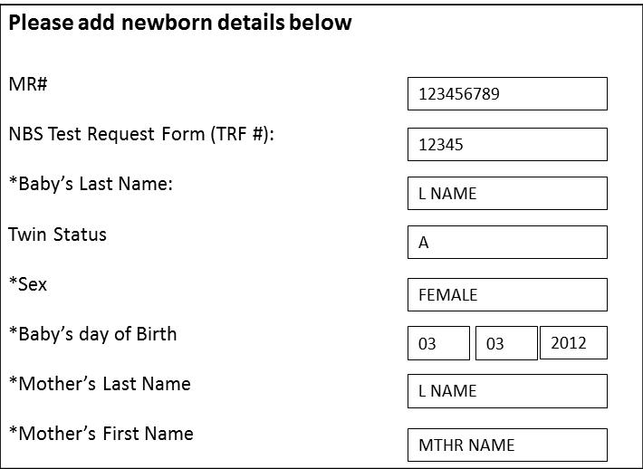  - Either MR# or NBS Test Request Form (TRF#) is required to input along with other mandatory fields shown with an asterisk  - Click Add to List  - The missing specimen is displayed in the Missing Specimens List grid  Note: The user can add multiple missing specimens by repeating steps 3 and 5 above  - Click on the radio button to update the missing specimen information.  - Click Edit  - Update the missing specimen by updating any of the fields displayed in the Please add newborn details below section  - Click Update  - Click Save to save all missing specimens reported. | Resend Result Mailer  - Select any specimen by checking the checkbox in the Received Specimen List.  - Click on the Resend Result Mailer button  - The Mailer Creation Date column will show Resend Requested if the request for duplicate result mailer was successful.  Note: Mailers are sent out the next business day.  - For specimens that have Pending or a mailer date less than 14 days from today, the following messages will be displayed:  If Pending: “The requested mailer has not been generated by SIS. Please wait 14 calendar days after Mailer Creation Date appears before requesting a duplicate mailer”.  If Less than 14 days: "The mailer is requested too soon. Please allow 14 calendar days from the Mailer Creation Date before requesting the mailer again".  Report Specimen Not Collected at Facility  - Select any specimen by checking the checkbox in the Received Specimen List.  - Click on the Report Specimen Not Collected At Facility button  - A confirmation box saying "This will remove the specimen(s) from the list. Click OK to confirm" will be displayed before the user proceeds to confirm the change. The message box will have 'OK' and 'Cancel' button in order to proceed.  - The selected specimen will be removed from the Received Specimen List once the user confirms the change.  View Missing Specimen Status  - Click View Missing Specimen Status on the 2nd level menu.  - Default view is a list of all the missing specimens with 'Reported' status. The specimens with status other than 'Reported' will be shown for 14 calendar days. The view will be specific to the logged on user’s hospital.  - Search for a missing specimen to view its status by entering at least two search criteria or entering only the TRF#.  - The search results are displayed in the Specimen Reported Missing grid in a two level sort. First level will be on the field Status (Reported status will be shown first) and second level is descending order on the field Date Reported.  - Click any column heading to sort by that column.  - SIS will display the status of the missing specimen as one of the following:  - Reported  - Collected at Your Facility  - Collected at Another Facility  - Not Found - Referred to the ASC for Follow up

